**1.Summary**

The project Hospital Healthcare Management System(HHMS) is for computerizing the working in a hospital, collection and storing data related to patients treatment, associated persons & accessories. The data stored in database with the ease of retrieval, update and analyze whenever needed. After tests, It generates test reports; provide prescription details including various tests, check-up and medicines prescribed to patient and doctor. It also provides injection details and billing facility. The system also provides the facility of backup as per the requirement. It needs everyday review and continuous amendments in the technology. Hence research & development is the core need and day to day improvements with amendment which is vital things for the healthcare database system.

**2.Approach**

entities: doctor, patient, staff, diagnosis, bill, test(include different tests databases),

prescription, medicine, injection, diet advice.

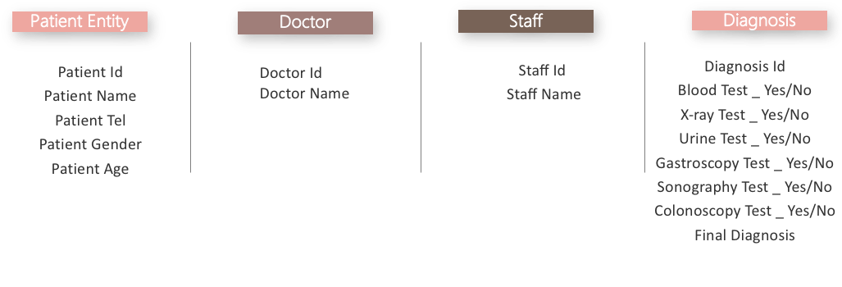

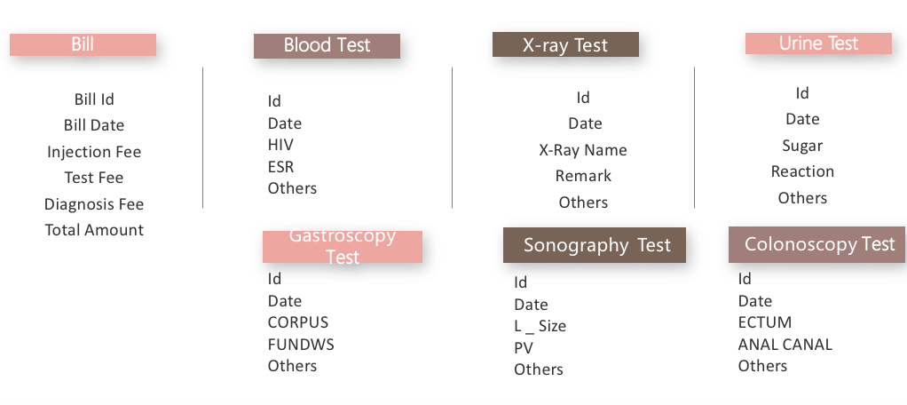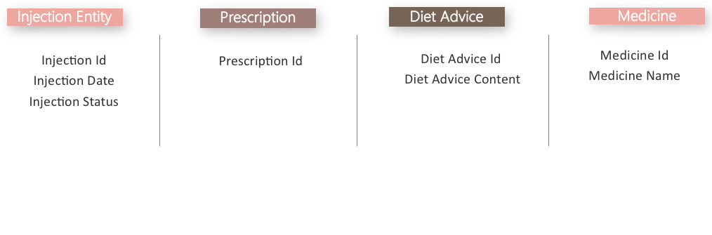

**3.System Operation Process**

Patient: they go to hospital, and they have own patient information, then

Doctor: make prescriptions for patients, then

Prescription: arrange different test: include blood test, urine test, sonography test, colonoscopy test, x ray test, and gastroscopy test, causing test fee, and prescriptions also generate the diet advices and medicine and injection issue; then

Diagnosis: from these test results, and cause diagnosis fee, then

Bill: include all of fee : diagnosis fee, injection fee, test fee, medicine fee, then

Patient get the bill to check out and pay.

**4.Use Case Diagram**

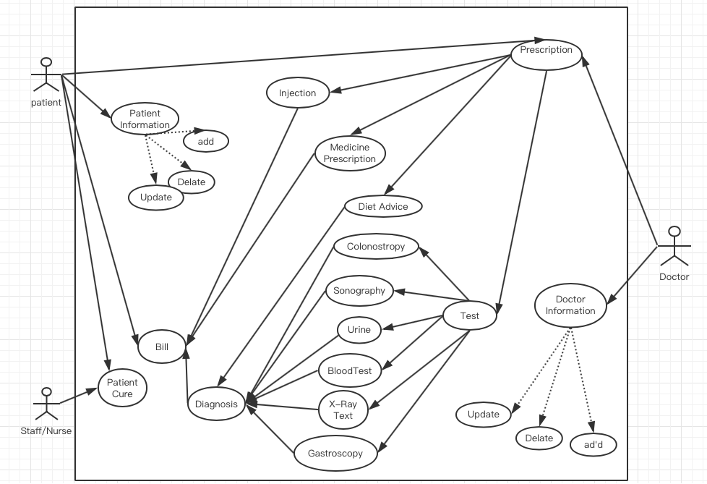

**5.ER Diagram**



**Final ER diagram**

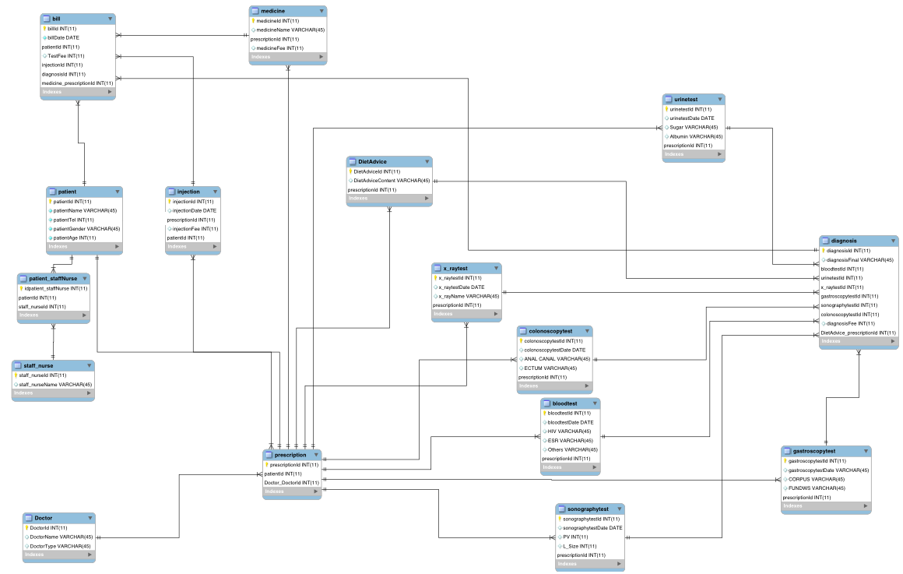

**5.** **neat SQL queries to do some analytics**

**View:**

create VIEW view1 AS

SELECT patientId,patientName,patientAge,(select count(patientAge) from patient) as totalAge

FROM patient inner join staff_nurse

on patient.patientId=staff_nurse.staff_nurseId and staff_nurse.staff_nurseId<4;

select * from view1;

create VIEW view2 AS

SELECT patient.patientName, injection.injectionDate,injection.injectionFee,bill.billId

FROM patient inner join bill inner join injection

on injection.injectionId=bill.injectionId

and bill.patientId=patient.patientId

and year(injectionDate) in (select bill.billDate from bill);

select * from view2;

create VIEW view3 AS

select prescription.doctorId ,Doctor.DoctorName,DietAdvice.DietAdviceContent,prescription.patientId

from Doctor ,DietAdvice,prescription

where exists

(select * from prescription

where prescription.patientId>1

and exists(select * from DietAdvice where DietAdvice.prescriptionId=prescription.prescriptionId

and DietAdvice.DietAdviceContent<5));

select * from view3;

**procedure:**

DELIMITER //

CREATE PROCEDURE patient_injectionDate_yearConstraint(IN year1 int, in year2 int,in year3 int)

BEGIN

declare FirstYear int;

declare SecondYear int;

declare thirdYear int;

set FirstYear = year1;

set SecondYear = year2;

set ThirdYear = year3;

select patient.patientId,patient.patientName, patient.patientGender,injection.injectionId,injection.injectionFee,injection.injectionDate,bill.billId

from patient inner join injection inner join bill

on bill.injectionId=injection.injectionId and patient.patientId=bill.patientId

and year(injection.injectionDate) not in (FirstYear,SecondYear,ThirdYear);

END //

DELIMITER ;

call patient_injectionDate_yearConstraint(2012, 2009,2016);

DELIMITER //

CREATE PROCEDURE patient_bloodtest_urinetest_result(IN patient1 int, in patient2 int)

BEGIN

declare FirstPatient int;

declare SecondPatient int;

set FirstPatient = patient1;

set SecondPatient = patient2;

select prescription.patientId,patient.patientAge,patient.patientGender,

bloodtest.bloodtestId,bloodtest.bloodtestDate,bloodtest.HIV,bloodtest.ESR,

urinetest.urinetestid,urinetest.urinetestDate,urinetest.Sugar,urinetest.Album

from patient inner join prescription inner join bloodtest inner join urinetest

on patient.patientId=prescription.patientId

and prescription.prescriptionId=bloodtest.prescriptionId

and prescription.prescriptionId=urinetest.prescriptionId

and patient.patientId in (FirstPatient,SecondPatient);

END //

DELIMITER ;

call patient_bloodtest_urinetest_result(2,5);

DELIMITER //

CREATE PROCEDURE patient_bill_dietadvice_medicine_result(IN patient1 int, in patient2 int)

BEGIN

declare FirstPatient int;

declare SecondPatient int;

set FirstPatient = patient1;

set SecondPatient = patient2;

select prescription.patientId,patient.patientAge,patient.patientGender,

bill.medicineId,medicine.medicineFee,medicine.medicineName,

prescription.prescriptionId,DietAdvice.DietAdviceContent

from patient inner join bill inner join medicine inner join dietAdvice inner join prescription

on bill.patientId=patient.patientId

and bill.medicineId=medicine.medicineId

and prescription.prescriptionId=patient.patientId

and prescription.prescriptionId=DietAdvice.prescriptionId

and patient.patientId in (FirstPatient,SecondPatient);

END //

DELIMITER ;

call patient_bill_dietadvice_medicine_result(3,4);

**Trigger:**

DELIMITER //

CREATE TRIGGER ahead_insert

before INSERT ON staff_Info

FOR EACH ROW

BEGIN

set new.fullname=concat(new.firstname,'',new.lastname);

END;//

show triggers;

insert into staff_info(firstname,lastname,staffId) values('Kavin','hhhh',1);

select * from staff_info;

DELIMITER //

CREATE TRIGGER ahead_update

before update ON staff_Info

FOR EACH ROW

BEGIN

set new.fullname=concat(new.firstname,'',new.lastname);

END;//

update staff_Info set firstname='hhh',lastname='rrr';

**Create user , Grant, Revoke:**

CREATE USER manager IDENTIFIED BY '123456';

grant all on patient to manager;

CREATE USER testexcute IDENTIFIED BY '111';

grant all on x_raytest to testexcute;

grant all on bloodtest to testexcute;

grant all on colonoscopytest to testexcute;

grant all on sonographytest to testexcute;

grant all on urinetest to testexcute;

grant all on gastroscopytest to testexcute;

grant select on prescription to testexcute;

REVOKE INSERT ON prescription FROM testexcute;

**6.Export final project backup word**

**-- MySQL dump 10.13 Distrib 8.0.13, for macos10.14 (x86_64)**

**--**

**-- Host: 127.0.0.1 Database: project_final**

**-- ------------------------------------------------------**

**-- Server version 8.0.13**

**/*!40101 SET @OLD_CHARACTER_SET_CLIENT=@@CHARACTER_SET_CLIENT */;**

**/*!40101 SET @OLD_CHARACTER_SET_RESULTS=@@CHARACTER_SET_RESULTS */;**

**/*!40101 SET @OLD_COLLATION_CONNECTION=@@COLLATION_CONNECTION */;**

**SET NAMES utf8 ;**

**/*!40103 SET @OLD_TIME_ZONE=@@TIME_ZONE */;**

**/*!40103 SET TIME_ZONE='+00:00' */;**

**/*!40014 SET @OLD_UNIQUE_CHECKS=@@UNIQUE_CHECKS, UNIQUE_CHECKS=0 */;**

**/*!40014 SET @OLD_FOREIGN_KEY_CHECKS=@@FOREIGN_KEY_CHECKS, FOREIGN_KEY_CHECKS=0 */;**

**/*!40101 SET @OLD_SQL_MODE=@@SQL_MODE, SQL_MODE='NO_AUTO_VALUE_ON_ZERO' */;**

**/*!40111 SET @OLD_SQL_NOTES=@@SQL_NOTES, SQL_NOTES=0 */;**

**--**

**-- Table structure for table `bill`**

**--**

**DROP TABLE IF EXISTS `bill`;**

**/*!40101 SET @saved_cs_client = @@character_set_client */;**

**SET character_set_client = utf8mb4 ;**

**CREATE TABLE `bill` (**

**`billId` int(11) NOT NULL,**

**`billDate` varchar(45) DEFAULT NULL,**

**`patientId` int(11) DEFAULT NULL,**

**`TestFee` int(11) DEFAULT NULL,**

**`injectionId` int(11) DEFAULT NULL,**

**`diagnosisId` int(11) DEFAULT NULL,**

**`medicineId` int(11) DEFAULT NULL,**

**PRIMARY KEY (`billId`),**

**KEY `fk_bill_patient` (`patientId`),**

**KEY `fk_bill_injection` (`injectionId`),**

**KEY `fk_bill_dia` (`diagnosisId`),**

**KEY `fk_bill_med` (`medicineId`),**

**CONSTRAINT `fk_bill_dia` FOREIGN KEY (`diagnosisId`) REFERENCES `diagnosis` (`diagnosisid`),**

**CONSTRAINT `fk_bill_injection` FOREIGN KEY (`injectionId`) REFERENCES `injection` (`injectionid`),**

**CONSTRAINT `fk_bill_med` FOREIGN KEY (`medicineId`) REFERENCES `medicine` (`medicineid`),**

**CONSTRAINT `fk_bill_patient` FOREIGN KEY (`patientId`) REFERENCES `patient` (`patientid`)**

**) ENGINE=InnoDB DEFAULT CHARSET=utf8mb4 COLLATE=utf8mb4_0900_ai_ci;**

**/*!40101 SET character_set_client = @saved_cs_client */;**

**--**

**-- Dumping data for table `bill`**

**--**

**LOCK TABLES `bill` WRITE;**

**/*!40000 ALTER TABLE `bill` DISABLE KEYS */;**

**INSERT INTO `bill` VALUES (1,'2016-12-12',1,100,1,1,1),(2,'2015-09-09',2,100,2,3,2),(3,'2015-01-13',3,100,3,2,3),(4,'2015-11-07',4,100,4,5,4),(5,'2015-12-02',5,100,5,4,5);**

**/*!40000 ALTER TABLE `bill` ENABLE KEYS */;**

**UNLOCK TABLES;**

**--**

**-- Table structure for table `bloodtest`**

**--**

**DROP TABLE IF EXISTS `bloodtest`;**

**/*!40101 SET @saved_cs_client = @@character_set_client */;**

**SET character_set_client = utf8mb4 ;**

**CREATE TABLE `bloodtest` (**

**`bloodtestId` int(11) NOT NULL,**

**`bloodtestDate` varchar(45) DEFAULT NULL,**

**`HIV` varchar(45) DEFAULT NULL,**

**`ESR` varchar(45) DEFAULT NULL,**

**`prescriptionId` int(11) DEFAULT NULL,**

**PRIMARY KEY (`bloodtestId`),**

**KEY `fk_blood_presc` (`prescriptionId`),**

**CONSTRAINT `fk_blood_presc` FOREIGN KEY (`prescriptionId`) REFERENCES `prescription` (`prescriptionid`)**

**) ENGINE=InnoDB DEFAULT CHARSET=utf8mb4 COLLATE=utf8mb4_0900_ai_ci;**

**/*!40101 SET character_set_client = @saved_cs_client */;**

**--**

**-- Dumping data for table `bloodtest`**

**--**

**LOCK TABLES `bloodtest` WRITE;**

**/*!40000 ALTER TABLE `bloodtest` DISABLE KEYS */;**

**INSERT INTO `bloodtest` VALUES (1,'2013-04-05','negative','positiver',1),(2,'2013-04-05','possitive','positive',2),(3,'2014-05-06','positive','negative',3),(4,'2013-06-25','negative','negative',4),(5,'2013-05-05','negative','positive',5);**

**/*!40000 ALTER TABLE `bloodtest` ENABLE KEYS */;**

**UNLOCK TABLES;**

**--**

**-- Table structure for table `colonoscopytest`**

**--**

**DROP TABLE IF EXISTS `colonoscopytest`;**

**/*!40101 SET @saved_cs_client = @@character_set_client */;**

**SET character_set_client = utf8mb4 ;**

**CREATE TABLE `colonoscopytest` (**

**`colonoscopytestId` int(11) NOT NULL,**

**`colonoscopytestDate` varchar(45) DEFAULT NULL,**

**`ANAL` int(11) DEFAULT NULL,**

**`ECTUM` int(11) DEFAULT NULL,**

**`prescriptionId` int(11) DEFAULT NULL,**

**PRIMARY KEY (`colonoscopytestId`),**

**KEY `fk_c_presc` (`prescriptionId`),**

**CONSTRAINT `fk_c_presc` FOREIGN KEY (`prescriptionId`) REFERENCES `prescription` (`prescriptionid`)**

**) ENGINE=InnoDB DEFAULT CHARSET=utf8mb4 COLLATE=utf8mb4_0900_ai_ci;**

**/*!40101 SET character_set_client = @saved_cs_client */;**

**--**

**-- Dumping data for table `colonoscopytest`**

**--**

**LOCK TABLES `colonoscopytest` WRITE;**

**/*!40000 ALTER TABLE `colonoscopytest` DISABLE KEYS */;**

**INSERT INTO `colonoscopytest` VALUES (1,'2012-06-05',3,4,1),(2,'2014-12-12',4,6,2),(3,'2016-01-18',7,4,3),(4,'2014-06-25',8,4,4),(5,'2013-05-05',7,2,5);**

**/*!40000 ALTER TABLE `colonoscopytest` ENABLE KEYS */;**

**UNLOCK TABLES;**

**--**

**-- Table structure for table `diagnosis`**

**--**

**DROP TABLE IF EXISTS `diagnosis`;**

**/*!40101 SET @saved_cs_client = @@character_set_client */;**

**SET character_set_client = utf8mb4 ;**

**CREATE TABLE `diagnosis` (**

**`diagnosisId` int(11) NOT NULL,**

**`diagnosisFinal` varchar(45) DEFAULT NULL,**

**`bloodtestId` int(11) DEFAULT NULL,**

**`urinetestId` int(11) DEFAULT NULL,**

**`x_raytestId` int(11) DEFAULT NULL,**

**`gastroscopytestId` int(11) DEFAULT NULL,**

**`colonoscopytestId` int(11) DEFAULT NULL,**

**`sonographytestId` int(11) DEFAULT NULL,**

**`dietadviceId` int(11) DEFAULT NULL,**

**`diagnosisFee` int(11) DEFAULT NULL,**

**PRIMARY KEY (`diagnosisId`),**

**KEY `fk_d_blood` (`bloodtestId`),**

**KEY `fk_d_x` (`x_raytestId`),**

**KEY `fk_d_c` (`colonoscopytestId`),**

**KEY `fk_d_s` (`sonographytestId`),**

**KEY `fk_d_g` (`gastroscopytestId`),**

**KEY `fk_d_u` (`urinetestId`),**

**KEY `fk_d_diet` (`dietadviceId`),**

**CONSTRAINT `fk_d_blood` FOREIGN KEY (`bloodtestId`) REFERENCES `bloodtest` (`bloodtestid`),**

**CONSTRAINT `fk_d_c` FOREIGN KEY (`colonoscopytestId`) REFERENCES `colonoscopytest` (`colonoscopytestid`),**

**CONSTRAINT `fk_d_diet` FOREIGN KEY (`dietadviceId`) REFERENCES `dietadvice` (`dietadviceid`),**

**CONSTRAINT `fk_d_g` FOREIGN KEY (`gastroscopytestId`) REFERENCES `gastroscopytest` (`gastroscopytestid`),**

**CONSTRAINT `fk_d_s` FOREIGN KEY (`sonographytestId`) REFERENCES `sonographytest` (`sonographytestid`),**

**CONSTRAINT `fk_d_u` FOREIGN KEY (`urinetestId`) REFERENCES `urinetest` (`urinetestid`),**

**CONSTRAINT `fk_d_x` FOREIGN KEY (`x_raytestId`) REFERENCES `x_raytest` (`x_raytestid`)**

**) ENGINE=InnoDB DEFAULT CHARSET=utf8mb4 COLLATE=utf8mb4_0900_ai_ci;**

**/*!40101 SET character_set_client = @saved_cs_client */;**

**--**

**-- Dumping data for table `diagnosis`**

**--**

**LOCK TABLES `diagnosis` WRITE;**

**/*!40000 ALTER TABLE `diagnosis` DISABLE KEYS */;**

**INSERT INTO `diagnosis` VALUES (1,'some cure',1,1,1,1,1,1,1,100),(2,'more cure',2,4,3,2,2,2,3,300),(3,'2some cure',3,5,2,3,3,3,2,200),(4,'some cure',5,2,4,4,4,4,4,340),(5,'more cure',4,3,5,5,5,5,5,100);**

**/*!40000 ALTER TABLE `diagnosis` ENABLE KEYS */;**

**UNLOCK TABLES;**

**--**

**-- Table structure for table `dietadvice`**

**--**

**DROP TABLE IF EXISTS `dietadvice`;**

**/*!40101 SET @saved_cs_client = @@character_set_client */;**

**SET character_set_client = utf8mb4 ;**

**CREATE TABLE `dietadvice` (**

**`dietadviceId` int(11) NOT NULL,**

**`dietadviceContent` varchar(45) DEFAULT NULL,**

**`prescriptionId` int(11) DEFAULT NULL,**

**PRIMARY KEY (`dietadviceId`),**

**KEY `fk_prescription_diet` (`prescriptionId`),**

**CONSTRAINT `fk_prescription_diet` FOREIGN KEY (`prescriptionId`) REFERENCES `prescription` (`prescriptionid`)**

**) ENGINE=InnoDB DEFAULT CHARSET=utf8mb4 COLLATE=utf8mb4_0900_ai_ci;**

**/*!40101 SET character_set_client = @saved_cs_client */;**

**--**

**-- Dumping data for table `dietadvice`**

**--**

**LOCK TABLES `dietadvice` WRITE;**

**/*!40000 ALTER TABLE `dietadvice` DISABLE KEYS */;**

**INSERT INTO `dietadvice` VALUES (1,'more seafood',1),(2,'more vegetable',2),(3,'more meat',3),(4,'less seafood',4),(5,'less meat',5);**

**/*!40000 ALTER TABLE `dietadvice` ENABLE KEYS */;**

**UNLOCK TABLES;**

**--**

**-- Table structure for table `doctor`**

**--**

**DROP TABLE IF EXISTS `doctor`;**

**/*!40101 SET @saved_cs_client = @@character_set_client */;**

**SET character_set_client = utf8mb4 ;**

**CREATE TABLE `doctor` (**

**`doctorId` int(11) NOT NULL,**

**`doctorName` varchar(45) DEFAULT NULL,**

**PRIMARY KEY (`doctorId`)**

**) ENGINE=InnoDB DEFAULT CHARSET=utf8mb4 COLLATE=utf8mb4_0900_ai_ci;**

**/*!40101 SET character_set_client = @saved_cs_client */;**

**--**

**-- Dumping data for table `doctor`**

**--**

**LOCK TABLES `doctor` WRITE;**

**/*!40000 ALTER TABLE `doctor` DISABLE KEYS */;**

**INSERT INTO `doctor` VALUES (1,'rr'),(2,'gg'),(3,'fg'),(4,'dd'),(5,'fr');**

**/*!40000 ALTER TABLE `doctor` ENABLE KEYS */;**

**UNLOCK TABLES;**

**--**

**-- Table structure for table `gastroscopytest`**

**--**

**DROP TABLE IF EXISTS `gastroscopytest`;**

**/*!40101 SET @saved_cs_client = @@character_set_client */;**

**SET character_set_client = utf8mb4 ;**

**CREATE TABLE `gastroscopytest` (**

**`gastroscopytestId` int(11) NOT NULL,**

**`gastroscopytestDate` varchar(45) DEFAULT NULL,**

**`CORPUS` varchar(45) DEFAULT NULL,**

**`FUNDWS` varchar(45) DEFAULT NULL,**

**`prescriptionId` int(11) DEFAULT NULL,**

**PRIMARY KEY (`gastroscopytestId`),**

**KEY `fk_g_presc` (`prescriptionId`),**

**CONSTRAINT `fk_g_presc` FOREIGN KEY (`prescriptionId`) REFERENCES `prescription` (`prescriptionid`)**

**) ENGINE=InnoDB DEFAULT CHARSET=utf8mb4 COLLATE=utf8mb4_0900_ai_ci;**

**/*!40101 SET character_set_client = @saved_cs_client */;**

**--**

**-- Dumping data for table `gastroscopytest`**

**--**

**LOCK TABLES `gastroscopytest` WRITE;**

**/*!40000 ALTER TABLE `gastroscopytest` DISABLE KEYS */;**

**INSERT INTO `gastroscopytest` VALUES (1,'2012-06-05','2','4',1),(2,'2013-12-12','3','6',2),(3,'2016-06-18','7','5',3),(4,'2014-06-25','8','4',4),(5,'2013-07-05','7','2',5);**

**/*!40000 ALTER TABLE `gastroscopytest` ENABLE KEYS */;**

**UNLOCK TABLES;**

**--**

**-- Table structure for table `injection`**

**--**

**DROP TABLE IF EXISTS `injection`;**

**/*!40101 SET @saved_cs_client = @@character_set_client */;**

**SET character_set_client = utf8mb4 ;**

**CREATE TABLE `injection` (**

**`injectionId` int(11) NOT NULL,**

**`injectionDate` varchar(45) DEFAULT NULL,**

**`prescriptionId` int(11) DEFAULT NULL,**

**`injectionFee` int(11) DEFAULT NULL,**

**PRIMARY KEY (`injectionId`),**

**KEY `fk_prescription_inje` (`prescriptionId`),**

**CONSTRAINT `fk_prescription_inje` FOREIGN KEY (`prescriptionId`) REFERENCES `prescription` (`prescriptionid`)**

**) ENGINE=InnoDB DEFAULT CHARSET=utf8mb4 COLLATE=utf8mb4_0900_ai_ci;**

**/*!40101 SET character_set_client = @saved_cs_client */;**

**--**

**-- Dumping data for table `injection`**

**--**

**LOCK TABLES `injection` WRITE;**

**/*!40000 ALTER TABLE `injection` DISABLE KEYS */;**

**INSERT INTO `injection` VALUES (1,'2015-12-12',1,20),(2,'2015-09-09',2,20),(3,'2016-08-08',3,30),(4,'2015-11-07',4,20),(5,'2015-12-02',5,30);**

**/*!40000 ALTER TABLE `injection` ENABLE KEYS */;**

**UNLOCK TABLES;**

**--**

**-- Table structure for table `medicine`**

**--**

**DROP TABLE IF EXISTS `medicine`;**

**/*!40101 SET @saved_cs_client = @@character_set_client */;**

**SET character_set_client = utf8mb4 ;**

**CREATE TABLE `medicine` (**

**`medicineId` int(11) NOT NULL,**

**`medicineName` varchar(45) DEFAULT NULL,**

**`prescriptionId` int(11) DEFAULT NULL,**

**`medicineFee` int(11) DEFAULT NULL,**

**PRIMARY KEY (`medicineId`),**

**KEY `fk_prescription_medi` (`prescriptionId`),**

**CONSTRAINT `fk_prescription_medi` FOREIGN KEY (`prescriptionId`) REFERENCES `prescription` (`prescriptionid`)**

**) ENGINE=InnoDB DEFAULT CHARSET=utf8mb4 COLLATE=utf8mb4_0900_ai_ci;**

**/*!40101 SET character_set_client = @saved_cs_client */;**

**--**

**-- Dumping data for table `medicine`**

**--**

**LOCK TABLES `medicine` WRITE;**

**/*!40000 ALTER TABLE `medicine` DISABLE KEYS */;**

**INSERT INTO `medicine` VALUES (1,'fre',1,200),(2,'gtr',2,40),(3,'bhu',3,50),(4,'lkkm',4,100),(5,'lppi',5,130);**

**/*!40000 ALTER TABLE `medicine` ENABLE KEYS */;**

**UNLOCK TABLES;**

**--**

**-- Table structure for table `patient`**

**--**

**DROP TABLE IF EXISTS `patient`;**

**/*!40101 SET @saved_cs_client = @@character_set_client */;**

**SET character_set_client = utf8mb4 ;**

**CREATE TABLE `patient` (**

**`patientId` int(11) NOT NULL,**

**`patientName` varchar(45) DEFAULT NULL,**

**`patientAge` int(11) DEFAULT NULL,**

**`patientGender` varchar(45) DEFAULT NULL,**

**PRIMARY KEY (`patientId`)**

**) ENGINE=InnoDB DEFAULT CHARSET=utf8mb4 COLLATE=utf8mb4_0900_ai_ci;**

**/*!40101 SET character_set_client = @saved_cs_client */;**

**--**

**-- Dumping data for table `patient`**

**--**

**LOCK TABLES `patient` WRITE;**

**/*!40000 ALTER TABLE `patient` DISABLE KEYS */;**

**INSERT INTO `patient` VALUES (1,'w',22,'f'),(2,'e',23,'m'),(3,'r',44,'f'),(4,'t',12,'m'),(5,'g',18,'f');**

**/*!40000 ALTER TABLE `patient` ENABLE KEYS */;**

**UNLOCK TABLES;**

**--**

**-- Table structure for table `patient_staffnurse`**

**--**

**DROP TABLE IF EXISTS `patient_staffnurse`;**

**/*!40101 SET @saved_cs_client = @@character_set_client */;**

**SET character_set_client = utf8mb4 ;**

**CREATE TABLE `patient_staffnurse` (**

**`patient_staffnursed` int(11) NOT NULL,**

**`patientId` int(11) DEFAULT NULL,**

**`staffId` int(11) DEFAULT NULL,**

**PRIMARY KEY (`patient_staffnursed`),**

**KEY `fk_staff_` (`staffId`),**

**KEY `fk_patient` (`patientId`),**

**CONSTRAINT `fk_patient` FOREIGN KEY (`patientId`) REFERENCES `patient` (`patientid`),**

**CONSTRAINT `fk_staff_` FOREIGN KEY (`staffId`) REFERENCES `staff_nurse` (`staff_nurseid`)**

**) ENGINE=InnoDB DEFAULT CHARSET=utf8mb4 COLLATE=utf8mb4_0900_ai_ci;**

**/*!40101 SET character_set_client = @saved_cs_client */;**

**--**

**-- Dumping data for table `patient_staffnurse`**

**--**

**LOCK TABLES `patient_staffnurse` WRITE;**

**/*!40000 ALTER TABLE `patient_staffnurse` DISABLE KEYS */;**

**INSERT INTO `patient_staffnurse` VALUES (1,1,1),(2,2,3),(3,3,2),(4,4,4),(5,5,5);**

**/*!40000 ALTER TABLE `patient_staffnurse` ENABLE KEYS */;**

**UNLOCK TABLES;**

**--**

**-- Table structure for table `prescription`**

**--**

**DROP TABLE IF EXISTS `prescription`;**

**/*!40101 SET @saved_cs_client = @@character_set_client */;**

**SET character_set_client = utf8mb4 ;**

**CREATE TABLE `prescription` (**

**`prescriptionId` int(11) NOT NULL,**

**`doctorId` int(11) DEFAULT NULL,**

**`patientId` int(11) DEFAULT NULL,**

**PRIMARY KEY (`prescriptionId`),**

**KEY `fk_prescription_pat` (`patientId`),**

**KEY `fk_prescription_doc` (`doctorId`),**

**CONSTRAINT `fk_prescription_doc` FOREIGN KEY (`doctorId`) REFERENCES `doctor` (`doctorid`),**

**CONSTRAINT `fk_prescription_pat` FOREIGN KEY (`patientId`) REFERENCES `patient` (`patientid`)**

**) ENGINE=InnoDB DEFAULT CHARSET=utf8mb4 COLLATE=utf8mb4_0900_ai_ci;**

**/*!40101 SET character_set_client = @saved_cs_client */;**

**--**

**-- Dumping data for table `prescription`**

**--**

**LOCK TABLES `prescription` WRITE;**

**/*!40000 ALTER TABLE `prescription` DISABLE KEYS */;**

**INSERT INTO `prescription` VALUES (1,2,2),(2,1,1),(3,4,4),(4,5,1),(5,1,5);**

**/*!40000 ALTER TABLE `prescription` ENABLE KEYS */;**

**UNLOCK TABLES;**

**--**

**-- Table structure for table `sonographytest`**

**--**

**DROP TABLE IF EXISTS `sonographytest`;**

**/*!40101 SET @saved_cs_client = @@character_set_client */;**

**SET character_set_client = utf8mb4 ;**

**CREATE TABLE `sonographytest` (**

**`sonographytestId` int(11) NOT NULL,**

**`sonographytestDate` varchar(45) DEFAULT NULL,**

**`PV` int(11) DEFAULT NULL,**

**`L_SIZE` int(11) DEFAULT NULL,**

**`prescriptionId` int(11) DEFAULT NULL,**

**PRIMARY KEY (`sonographytestId`),**

**KEY `fk_s_presc` (`prescriptionId`),**

**CONSTRAINT `fk_s_presc` FOREIGN KEY (`prescriptionId`) REFERENCES `prescription` (`prescriptionid`)**

**) ENGINE=InnoDB DEFAULT CHARSET=utf8mb4 COLLATE=utf8mb4_0900_ai_ci;**

**/*!40101 SET character_set_client = @saved_cs_client */;**

**--**

**-- Dumping data for table `sonographytest`**

**--**

**LOCK TABLES `sonographytest` WRITE;**

**/*!40000 ALTER TABLE `sonographytest` DISABLE KEYS */;**

**INSERT INTO `sonographytest` VALUES (1,'2012-11-05',7,4,1),(2,'2013-10-12',4,6,2),(3,'2016-11-18',7,4,3),(4,'2014-06-25',6,4,4),(5,'2013-04-05',7,2,5);**

**/*!40000 ALTER TABLE `sonographytest` ENABLE KEYS */;**

**UNLOCK TABLES;**

**--**

**-- Table structure for table `staff_Info`**

**--**

**DROP TABLE IF EXISTS `staff_Info`;**

**/*!40101 SET @saved_cs_client = @@character_set_client */;**

**SET character_set_client = utf8mb4 ;**

**CREATE TABLE `staff_Info` (**

**`firstname` varchar(45) NOT NULL,**

**`lastname` varchar(45) DEFAULT NULL,**

**`fullname` varchar(45) DEFAULT NULL,**

**`staffId` int(11) DEFAULT NULL,**

**PRIMARY KEY (`firstname`),**

**KEY `fk_staff_info` (`staffId`),**

**CONSTRAINT `fk_staff_info` FOREIGN KEY (`staffId`) REFERENCES `staff_nurse` (`staff_nurseid`)**

**) ENGINE=InnoDB DEFAULT CHARSET=utf8mb4 COLLATE=utf8mb4_0900_ai_ci;**

**/*!40101 SET character_set_client = @saved_cs_client */;**

**--**

**-- Dumping data for table `staff_Info`**

**--**

**LOCK TABLES `staff_Info` WRITE;**

**/*!40000 ALTER TABLE `staff_Info` DISABLE KEYS */;**

**INSERT INTO `staff_Info` VALUES ('hhh','rrr','hhhrrr',1);**

**/*!40000 ALTER TABLE `staff_Info` ENABLE KEYS */;**

**UNLOCK TABLES;**

**--**

**-- WARNING: old server version. The following dump may be incomplete.**

**--**

**DELIMITER ;;**

**/*!50003 SET SESSION SQL_MODE="ONLY_FULL_GROUP_BY,STRICT_TRANS_TABLES,NO_ZERO_IN_DATE,NO_ZERO_DATE,ERROR_FOR_DIVISION_BY_ZERO,NO_ENGINE_SUBSTITUTION" */;;**

**/*!50003 CREATE */ /*!50017 DEFINER=`root`@`localhost` */ /*!50003 TRIGGER `ahead_insert` BEFORE INSERT ON `staff_Info` FOR EACH ROW BEGIN**

**set new.fullname=concat(new.firstname,'',new.lastname);**

**END */;;**

**DELIMITER ;**

**--**

**-- WARNING: old server version. The following dump may be incomplete.**

**--**

**DELIMITER ;;**

**/*!50003 SET SESSION SQL_MODE="ONLY_FULL_GROUP_BY,STRICT_TRANS_TABLES,NO_ZERO_IN_DATE,NO_ZERO_DATE,ERROR_FOR_DIVISION_BY_ZERO,NO_ENGINE_SUBSTITUTION" */;;**

**/*!50003 CREATE */ /*!50017 DEFINER=`root`@`localhost` */ /*!50003 TRIGGER `ahead_update` BEFORE UPDATE ON `staff_Info` FOR EACH ROW BEGIN**

**set new.fullname=concat(new.firstname,'',new.lastname);**

**END */;;**

**DELIMITER ;**

**--**

**-- Table structure for table `staff_nurse`**

**--**

**DROP TABLE IF EXISTS `staff_nurse`;**

**/*!40101 SET @saved_cs_client = @@character_set_client */;**

**SET character_set_client = utf8mb4 ;**

**CREATE TABLE `staff_nurse` (**

**`staff_nurseId` int(11) NOT NULL,**

**PRIMARY KEY (`staff_nurseId`)**

**) ENGINE=InnoDB DEFAULT CHARSET=utf8mb4 COLLATE=utf8mb4_0900_ai_ci;**

**/*!40101 SET character_set_client = @saved_cs_client */;**

**--**

**-- Dumping data for table `staff_nurse`**

**--**

**LOCK TABLES `staff_nurse` WRITE;**

**/*!40000 ALTER TABLE `staff_nurse` DISABLE KEYS */;**

**INSERT INTO `staff_nurse` VALUES (1),(2),(3),(4),(5);**

**/*!40000 ALTER TABLE `staff_nurse` ENABLE KEYS */;**

**UNLOCK TABLES;**

**--**

**-- Table structure for table `urinetest`**

**--**

**DROP TABLE IF EXISTS `urinetest`;**

**/*!40101 SET @saved_cs_client = @@character_set_client */;**

**SET character_set_client = utf8mb4 ;**

**CREATE TABLE `urinetest` (**

**`urinetestId` int(11) NOT NULL,**

**`urinetestDate` varchar(45) DEFAULT NULL,**

**`SUGAR` varchar(45) DEFAULT NULL,**

**`ALBUM` varchar(45) DEFAULT NULL,**

**`prescriptionId` int(11) DEFAULT NULL,**

**PRIMARY KEY (`urinetestId`),**

**KEY `fk_u_presc` (`prescriptionId`),**

**CONSTRAINT `fk_u_presc` FOREIGN KEY (`prescriptionId`) REFERENCES `prescription` (`prescriptionid`)**

**) ENGINE=InnoDB DEFAULT CHARSET=utf8mb4 COLLATE=utf8mb4_0900_ai_ci;**

**/*!40101 SET character_set_client = @saved_cs_client */;**

**--**

**-- Dumping data for table `urinetest`**

**--**

**LOCK TABLES `urinetest` WRITE;**

**/*!40000 ALTER TABLE `urinetest` DISABLE KEYS */;**

**INSERT INTO `urinetest` VALUES (1,'2013-06-05','regular','high',1),(2,'2013-12-05','high','low',2),(3,'2016-01-06','regulaer','regular',3),(4,'2014-06-25','high','regular',4),(5,'2014-05-05','low','regular',5);**

**/*!40000 ALTER TABLE `urinetest` ENABLE KEYS */;**

**UNLOCK TABLES;**

**--**

**-- Temporary view structure for view `view1`**

**--**

**DROP TABLE IF EXISTS `view1`;**

**/*!50001 DROP VIEW IF EXISTS `view1`*/;**

**SET @saved_cs_client = @@character_set_client;**

**SET character_set_client = utf8mb4;**

**/*!50001 CREATE VIEW `view1` AS SELECT**

**1 AS `patientId`,**

**1 AS `patientName`,**

**1 AS `patientAge`,**

**1 AS `totalAge`*/;**

**SET character_set_client = @saved_cs_client;**

**--**

**-- Temporary view structure for view `view2`**

**--**

**DROP TABLE IF EXISTS `view2`;**

**/*!50001 DROP VIEW IF EXISTS `view2`*/;**

**SET @saved_cs_client = @@character_set_client;**

**SET character_set_client = utf8mb4;**

**/*!50001 CREATE VIEW `view2` AS SELECT**

**1 AS `patientName`,**

**1 AS `injectionDate`,**

**1 AS `injectionFee`,**

**1 AS `billId`*/;**

**SET character_set_client = @saved_cs_client;**

**--**

**-- Temporary view structure for view `view3`**

**--**

**DROP TABLE IF EXISTS `view3`;**

**/*!50001 DROP VIEW IF EXISTS `view3`*/;**

**SET @saved_cs_client = @@character_set_client;**

**SET character_set_client = utf8mb4;**

**/*!50001 CREATE VIEW `view3` AS SELECT**

**1 AS `doctorId`,**

**1 AS `DoctorName`,**

**1 AS `DietAdviceContent`,**

**1 AS `patientId`*/;**

**SET character_set_client = @saved_cs_client;**

**--**

**-- Table structure for table `x_raytest`**

**--**

**DROP TABLE IF EXISTS `x_raytest`;**

**/*!40101 SET @saved_cs_client = @@character_set_client */;**

**SET character_set_client = utf8mb4 ;**

**CREATE TABLE `x_raytest` (**

**`x_raytestId` int(11) NOT NULL,**

**`x_raytestDate` varchar(45) DEFAULT NULL,**

**`x_raytestName` varchar(45) DEFAULT NULL,**

**`prescriptionId` int(11) DEFAULT NULL,**

**PRIMARY KEY (`x_raytestId`),**

**KEY `fk_x_presc` (`prescriptionId`),**

**CONSTRAINT `fk_x_presc` FOREIGN KEY (`prescriptionId`) REFERENCES `prescription` (`prescriptionid`)**

**) ENGINE=InnoDB DEFAULT CHARSET=utf8mb4 COLLATE=utf8mb4_0900_ai_ci;**

**/*!40101 SET character_set_client = @saved_cs_client */;**

**--**

**-- Dumping data for table `x_raytest`**

**--**

**LOCK TABLES `x_raytest` WRITE;**

**/*!40000 ALTER TABLE `x_raytest` DISABLE KEYS */;**

**INSERT INTO `x_raytest` VALUES (1,'2013-04-05','www',1),(2,'2013-04-05','eee',2),(3,'2014-05-06','ttt',3),(4,'2013-06-25','mmm',4),(5,'2013-05-05','ttt',5);**

**/*!40000 ALTER TABLE `x_raytest` ENABLE KEYS */;**

**UNLOCK TABLES;**

**--**

**-- Dumping events for database 'project_final'**

**--**

**--**

**-- Dumping routines for database 'project_final'**

**--**

**/*!50003 DROP PROCEDURE IF EXISTS `patient_bill_dietadvice_medicine_result` */;**

**/*!50003 SET @saved_cs_client = @@character_set_client */ ;**

**/*!50003 SET @saved_cs_results = @@character_set_results */ ;**

**/*!50003 SET @saved_col_connection = @@collation_connection */ ;**

**/*!50003 SET character_set_client = utf8mb4 */ ;**

**/*!50003 SET character_set_results = utf8mb4 */ ;**

**/*!50003 SET collation_connection = utf8mb4_0900_ai_ci */ ;**

**/*!50003 SET @saved_sql_mode = @@sql_mode */ ;**

**/*!50003 SET sql_mode = 'ONLY_FULL_GROUP_BY,STRICT_TRANS_TABLES,NO_ZERO_IN_DATE,NO_ZERO_DATE,ERROR_FOR_DIVISION_BY_ZERO,NO_ENGINE_SUBSTITUTION' */ ;**

**DELIMITER ;;**

**CREATE DEFINER=`root`@`localhost` PROCEDURE `patient_bill_dietadvice_medicine_result`(IN patient1 int, in patient2 int)**

**BEGIN**

**declare FirstPatient int;**

**declare SecondPatient int;**

**set FirstPatient = patient1;**

**set SecondPatient = patient2;**

**select prescription.patientId,patient.patientAge,patient.patientGender,**

**bill.medicineId,medicine.medicineFee,medicine.medicineName,**

**prescription.prescriptionId,DietAdvice.DietAdviceContent**

**from patient inner join bill inner join medicine inner join dietAdvice inner join prescription**

**on bill.patientId=patient.patientId**

**and bill.medicineId=medicine.medicineId**

**and prescription.prescriptionId=patient.patientId**

**and prescription.prescriptionId=DietAdvice.prescriptionId**

**and patient.patientId in (FirstPatient,SecondPatient);**

**END ;;**

**DELIMITER ;**

**/*!50003 SET sql_mode = @saved_sql_mode */ ;**

**/*!50003 SET character_set_client = @saved_cs_client */ ;**

**/*!50003 SET character_set_results = @saved_cs_results */ ;**

**/*!50003 SET collation_connection = @saved_col_connection */ ;**

**/*!50003 DROP PROCEDURE IF EXISTS `patient_bloodtest_urinetest_result` */;**

**/*!50003 SET @saved_cs_client = @@character_set_client */ ;**

**/*!50003 SET @saved_cs_results = @@character_set_results */ ;**

**/*!50003 SET @saved_col_connection = @@collation_connection */ ;**

**/*!50003 SET character_set_client = utf8mb4 */ ;**

**/*!50003 SET character_set_results = utf8mb4 */ ;**

**/*!50003 SET collation_connection = utf8mb4_0900_ai_ci */ ;**

**/*!50003 SET @saved_sql_mode = @@sql_mode */ ;**

**/*!50003 SET sql_mode = 'ONLY_FULL_GROUP_BY,STRICT_TRANS_TABLES,NO_ZERO_IN_DATE,NO_ZERO_DATE,ERROR_FOR_DIVISION_BY_ZERO,NO_ENGINE_SUBSTITUTION' */ ;**

**DELIMITER ;;**

**CREATE DEFINER=`root`@`localhost` PROCEDURE `patient_bloodtest_urinetest_result`(IN patient1 int, in patient2 int)**

**BEGIN**

**declare FirstPatient int;**

**declare SecondPatient int;**

**set FirstPatient = patient1;**

**set SecondPatient = patient2;**

**select prescription.patientId,patient.patientAge,patient.patientGender,**

**bloodtest.bloodtestId,bloodtest.bloodtestDate,bloodtest.HIV,bloodtest.ESR,**

**urinetest.urinetestid,urinetest.urinetestDate,urinetest.Sugar,urinetest.Album**

**from patient inner join prescription inner join bloodtest inner join urinetest**

**on patient.patientId=prescription.patientId**

**and prescription.prescriptionId=bloodtest.prescriptionId**

**and prescription.prescriptionId=urinetest.prescriptionId**

**and patient.patientId in (FirstPatient,SecondPatient);**

**END ;;**

**DELIMITER ;**

**/*!50003 SET sql_mode = @saved_sql_mode */ ;**

**/*!50003 SET character_set_client = @saved_cs_client */ ;**

**/*!50003 SET character_set_results = @saved_cs_results */ ;**

**/*!50003 SET collation_connection = @saved_col_connection */ ;**

**/*!50003 DROP PROCEDURE IF EXISTS `patient_injectionDate_yearConstraint` */;**

**/*!50003 SET @saved_cs_client = @@character_set_client */ ;**

**/*!50003 SET @saved_cs_results = @@character_set_results */ ;**

**/*!50003 SET @saved_col_connection = @@collation_connection */ ;**

**/*!50003 SET character_set_client = utf8mb4 */ ;**

**/*!50003 SET character_set_results = utf8mb4 */ ;**

**/*!50003 SET collation_connection = utf8mb4_0900_ai_ci */ ;**

**/*!50003 SET @saved_sql_mode = @@sql_mode */ ;**

**/*!50003 SET sql_mode = 'ONLY_FULL_GROUP_BY,STRICT_TRANS_TABLES,NO_ZERO_IN_DATE,NO_ZERO_DATE,ERROR_FOR_DIVISION_BY_ZERO,NO_ENGINE_SUBSTITUTION' */ ;**

**DELIMITER ;;**

**CREATE DEFINER=`root`@`localhost` PROCEDURE `patient_injectionDate_yearConstraint`(IN year1 int, in year2 int,in year3 int)**

**BEGIN**

**declare FirstYear int;**

**declare SecondYear int;**

**declare thirdYear int;**

**set FirstYear = year1;**

**set SecondYear = year2;**

**set ThirdYear = year3;**

**select patient.patientId,patient.patientName, patient.patientGender,injection.injectionId,injection.injectionFee,injection.injectionDate,bill.billId**

**from patient inner join injection inner join bill**

**on bill.injectionId=injection.injectionId and patient.patientId=bill.patientId**

**and year(injection.injectionDate) not in (FirstYear,SecondYear,ThirdYear);**

**END ;;**

**DELIMITER ;**

**/*!50003 SET sql_mode = @saved_sql_mode */ ;**

**/*!50003 SET character_set_client = @saved_cs_client */ ;**

**/*!50003 SET character_set_results = @saved_cs_results */ ;**

**/*!50003 SET collation_connection = @saved_col_connection */ ;**

**--**

**-- Final view structure for view `view1`**

**--**

**/*!50001 DROP VIEW IF EXISTS `view1`*/;**

**/*!50001 SET @saved_cs_client = @@character_set_client */;**

**/*!50001 SET @saved_cs_results = @@character_set_results */;**

**/*!50001 SET @saved_col_connection = @@collation_connection */;**

**/*!50001 SET character_set_client = utf8mb4 */;**

**/*!50001 SET character_set_results = utf8mb4 */;**

**/*!50001 SET collation_connection = utf8mb4_0900_ai_ci */;**

**/*!50001 CREATE ALGORITHM=UNDEFINED */**

**/*!50013 DEFINER=`root`@`localhost` SQL SECURITY DEFINER */**

**/*!50001 VIEW `view1` AS select `patient`.`patientId` AS `patientId`,`patient`.`patientName` AS `patientName`,`patient`.`patientAge` AS `patientAge`,(select count(`patient`.`patientAge`) from `patient`) AS `totalAge` from (`patient` join `staff_nurse` on(((`patient`.`patientId` = `staff_nurse`.`staff_nurseId`) and (`staff_nurse`.`staff_nurseId` < 4)))) */;**

**/*!50001 SET character_set_client = @saved_cs_client */;**

**/*!50001 SET character_set_results = @saved_cs_results */;**

**/*!50001 SET collation_connection = @saved_col_connection */;**

**--**

**-- Final view structure for view `view2`**

**--**

**/*!50001 DROP VIEW IF EXISTS `view2`*/;**

**/*!50001 SET @saved_cs_client = @@character_set_client */;**

**/*!50001 SET @saved_cs_results = @@character_set_results */;**

**/*!50001 SET @saved_col_connection = @@collation_connection */;**

**/*!50001 SET character_set_client = utf8mb4 */;**

**/*!50001 SET character_set_results = utf8mb4 */;**

**/*!50001 SET collation_connection = utf8mb4_0900_ai_ci */;**

**/*!50001 CREATE ALGORITHM=UNDEFINED */**

**/*!50013 DEFINER=`root`@`localhost` SQL SECURITY DEFINER */**

**/*!50001 VIEW `view2` AS select `patient`.`patientName` AS `patientName`,`injection`.`injectionDate` AS `injectionDate`,`injection`.`injectionFee` AS `injectionFee`,`bill`.`billId` AS `billId` from ((`patient` join `bill`) join `injection` on(((`injection`.`injectionId` = `bill`.`injectionId`) and (`bill`.`patientId` = `patient`.`patientId`) and year(`injection`.`injectionDate`) in (select `bill`.`billDate` from `bill`)))) */;**

**/*!50001 SET character_set_client = @saved_cs_client */;**

**/*!50001 SET character_set_results = @saved_cs_results */;**

**/*!50001 SET collation_connection = @saved_col_connection */;**

**--**

**-- Final view structure for view `view3`**

**--**

**/*!50001 DROP VIEW IF EXISTS `view3`*/;**

**/*!50001 SET @saved_cs_client = @@character_set_client */;**

**/*!50001 SET @saved_cs_results = @@character_set_results */;**

**/*!50001 SET @saved_col_connection = @@collation_connection */;**

**/*!50001 SET character_set_client = utf8mb4 */;**

**/*!50001 SET character_set_results = utf8mb4 */;**

**/*!50001 SET collation_connection = utf8mb4_0900_ai_ci */;**

**/*!50001 CREATE ALGORITHM=UNDEFINED */**

**/*!50013 DEFINER=`root`@`localhost` SQL SECURITY DEFINER */**

**/*!50001 VIEW `view3` AS select `prescription`.`doctorId` AS `doctorId`,`doctor`.`doctorName` AS `DoctorName`,`dietadvice`.`dietadviceContent` AS `DietAdviceContent`,`prescription`.`patientId` AS `patientId` from ((`doctor` join `dietadvice`) join `prescription`) where exists(select 1 from `prescription` where ((`prescription`.`patientId` > 1) and exists(select 1 from `dietadvice` where ((`dietadvice`.`prescriptionId` = `prescription`.`prescriptionId`) and (`dietadvice`.`dietadviceContent` < 5))))) */;**

**/*!50001 SET character_set_client = @saved_cs_client */;**

**/*!50001 SET character_set_results = @saved_cs_results */;**

**/*!50001 SET collation_connection = @saved_col_connection */;**

**/*!40103 SET TIME_ZONE=@OLD_TIME_ZONE */;**

**/*!40101 SET SQL_MODE=@OLD_SQL_MODE */;**

**/*!40014 SET FOREIGN_KEY_CHECKS=@OLD_FOREIGN_KEY_CHECKS */;**

**/*!40014 SET UNIQUE_CHECKS=@OLD_UNIQUE_CHECKS */;**

**/*!40101 SET CHARACTER_SET_CLIENT=@OLD_CHARACTER_SET_CLIENT */;**

**/*!40101 SET CHARACTER_SET_RESULTS=@OLD_CHARACTER_SET_RESULTS */;**

**/*!40101 SET COLLATION_CONNECTION=@OLD_COLLATION_CONNECTION */;**

**/*!40111 SET SQL_NOTES=@OLD_SQL_NOTES */;**

**-- Dump completed on 2018-12-13 7:38:59**